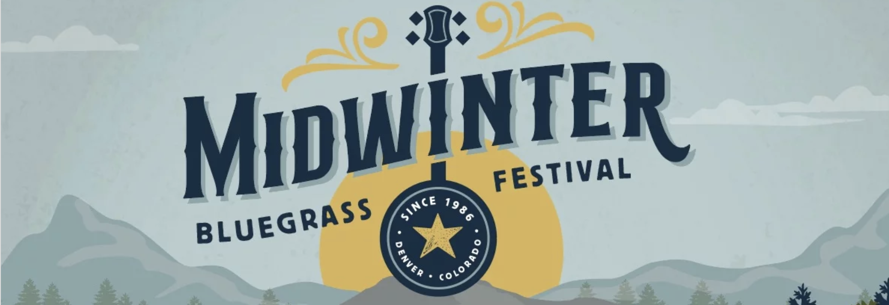

February 14-16, 2025
Delta Hotel by Marriott, Northglenn CO
10 East 120th Avenue, Northglenn, Colorado 80233
FESTIVAL BOOTH APPLICATION
(Print this page, enclose check, and send by U.S. Mail OR send by email to vendorcoordinator@ryegrassproductions.com along with payment information)

Company Name:
Contact Name:
Address:
City, State, Zip:
Phone:
Email:
(required)
Application Deadline: We will accept applications until all spaces are filled. Vendors will be reviewed for fit, with an effort made to minimize overlap of merchandise type (ie: probably no more than 3 jewelry vendors)
Acceptance notifications will be distributed on a rolling basis via email, along with a payment link. Fees due upon receipt of acceptance
Product description: Please describe the items you intend to sell. Enclose photos (or e-mail photos to vendorcoordinator@ryegrassproductions.com) if you are new to this festival. Please indicate if your merchandise is handmade by you. Please indicate if your display is taller than 6’ in height (tall displays are restricted to the side and back wall).

VENDORS WITH FOOD RELATED ITEMS: Please be aware that we will not be accepting applications for booths selling ready to eat food items.

VENDOR ACCEPTANCE: Our goal is to facilitate a vendor experience that benefits both the vendor and festival-goer, keeping in mind a good product/service mix, attractive and appropriate product and booth appearance, as well as a preference for local and quality crafted items. Vendor acceptance will be based on these criteria.

PRICING:
Inside Vendor Room: regular table is $175.00, and premium corner table is $200.oo.
Table In Atrium (only a few available): $225.00.
Each option includes standard 6’ table space and 2 weekend wristbands.
Applications are non-refundable unless the festival is cancelled for reasons out of our control.
How many table spaces are requested? _________________ Total Cost: _________
Your reservation is not confirmed until payment has been received. Checks will not be cashed until your application is approved. Spaces will be assigned at the discretion of the Vendor Coordinator. Returning vendors will be given preference in regard to space assignment.

VENDOR ADVERTISEMENTS: Vendor ad space in the Festival Program is available for an additional cost. Please indicate if you are interested and we will contact you with pricing: YES NO
APPLICATIONS ACCOMPANIED BY CHECK ARE DUE NO LATER THAN NOVEMBER 14th, 2024. If your application is not accepted and you are paying by check, your check will be destroyed.
MAKE CHECKS PAYABLE TO: Ryegrass Productions
EMAIL APPLICATIONS TO: vendorcoordinator@ryegrassproductions.com
OR - MAIL APPLICATION AND CHECK TO:
Ryegrass Productions, 1332 N Cascade Ave, Colorado Springs, CO 80903

Midwinter Bluegrass Festival, February 14-16, 2025
Delta Marriott Hotel (Formerly Ramada Inn), Northglenn CO
10 East 120th Avenue, Northglenn, Colorado 80233
I-25 and 120th Ave., Denver, Colorado

PARKING AND LOADING-IN: You will find it most convenient to park on the east side of the building
to load in through the double doors. We will open the double doors at 1:00 pm. We will also open the room from
the atrium side at the same time.

CHECK-IN/ SET UP: Friday, Feb. 14, 1:00 to 4:30 p.m.
We will not unlock the vendor room in Gray’s Peak until 1:00 pm. You will be provided with your wristbands as you are setting up, and tables will be marked to identify your placement.

EXHIBIT HALL OPEN HOURS:
Friday 4:30 p.m. - 9:30 p.m.
Saturday 10:00 a.m. - 9:30 p.m.
Sunday 10:00 a.m. - 6:00 p.m.
The festival starts at 5:00 pm on Friday February 14th.
CLOSING, MOVE OUT: Sunday 6:00 - 10:00 p.m.
These times are subject to change based on final performance schedule.

BOOTH SPACE DESCRIPTION: The space is approximately 8’ wide and includes a 6’ x 30” table, with roughly 2’ on one side to allow for passage between tables. There will be roughly 3’ of space behind each table, with 2 chairs provided. You will need to provide your own table covers.
- Each vendor will be provided with 2 weekend wristbands. If you have more than 2 workers, you will need to buy additional passes at the regular rate.
- Any display features that exceed 6’ in height are restricted to the back and side walls of the venue to prevent blocking sightlines through the vendor area.
- Spaces will be marked out prior to set-up and vendors must set up within those parameters.

SECURITY: the Vendor room will be locked Friday and Saturday nights. However, Midwinter Festival and Ryegrass Productions cannot assume liability for any stolen items since we do not control access to the Vendor room. Security of your merchandise is your responsibility. Tables set up in the atrium can only be secured if the merchandise is moved into the Vendor room at the end of each day.

SALES TAX: Vendors are required to have a valid Colorado sales tax license

QUESTIONS ABOUT THE VENDOR SPACE: please contact Karen Laman at vendorcoordinator@ryegrassproductions.com

Thank you, and we look forward to seeing you February 14th at the festival!

Please bring this sheet with you to the festival so you’ll have your show info handy
QUESTIONS/CONCERNS: please contact Karen Laman at vendorcoordinator@ryegrassproductions.com

